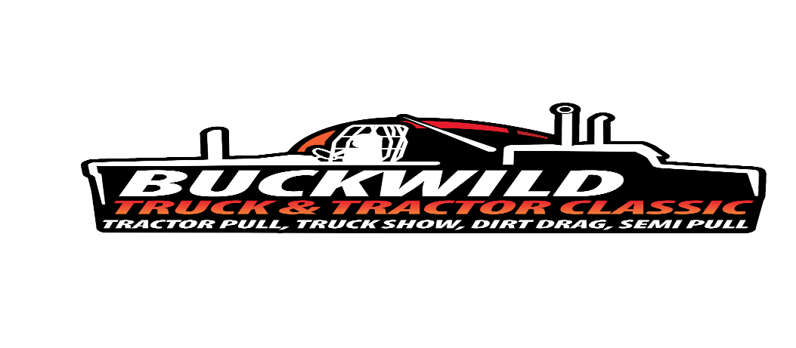

**BUCKWILD TRUCK & TRACTOR CLASSIC**

**WEEKEND SCHEDULE**

**Schedule subject to change**

**ADMISSION $15.00/DAY $25.00 WEEKEND PASS**

**Tickets will be available at the gate only**

**FOOD & BEER GARDEN AVAILABLE ON THE GROUNDS**

**No Outside Food & Alcohol Allowed on the grounds**

**Only Service pets allowed**

**FRIDAY, APRIL 25TH TRACTOR PULL**

* 4:00 PM – Gates Open
* 4:30 PM – Farm Stock Puller must be registered at the Finch Stage (Buck Miller arena)
* 5:00 PM – Farm Stock Pull
* 6:30 PM – Interstate Pullers must be registered at the Finch Stage (Buck Miller arena)
* 7:30 PM – Interstate Tractor Pull will start

**SATURDAY, APRIL 26TH TRUCK SHOW, DIRT & SEMI DRAGS, TRUCK PULL**

* 7:00 AM – Gates Open for Show Trucks to arrive
* 9:00 AM – Gates open for Spectators.
* 10:30 AM –Trucks must be registered for the Truck Show in the Shipley Building Office #2
* 11:00 AM – All Dirt Drag Drivers must be registered on the Finch Stage (Buck Miller arena)
* 11:30 PM - Truck Show Judging begins
* 11:30 AM –Dirt Drag Drivers Mandatory Meeting
* 12:00 PM – Test & Tune – 1 pass per truck
* 1:00 PM - Truck & Semi Drag Racing
* 3:00 PM - Truck Show trophies awarded in front of the Finch Stage
* 3:00 PM – Loser Bracket $5.00 for all preregistered dirt drag trucks (If time permits)
* 5:30 PM – Truck Pullers must be registered at at the Finch Stage (Buck Miller arena)
* 6:00 PM - Truck Pull